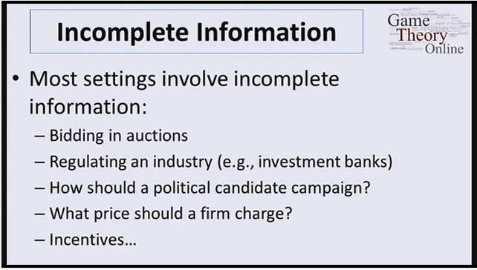
6 - 1 - Conflict Example -Game Theory-Matthew O. Jackson & Yoav Shoham
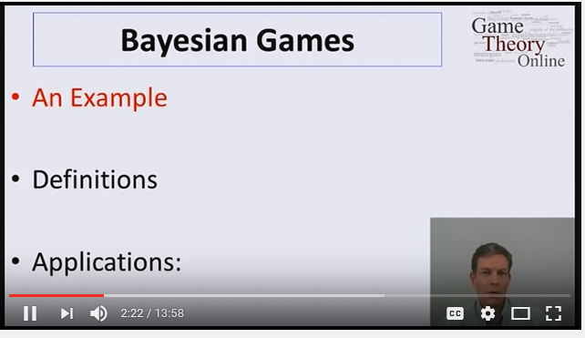

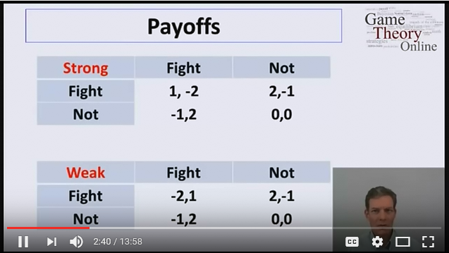

Player 1 comes in two forms: Strong or Weak.
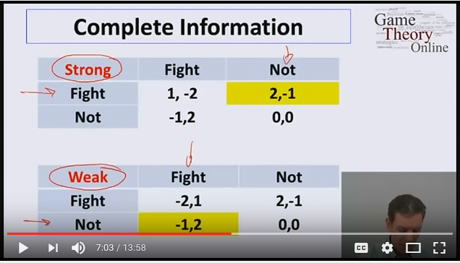
If both players have complete information than it is easy to analyze. But what if only Player 1 knows his type but Player 2 does not.
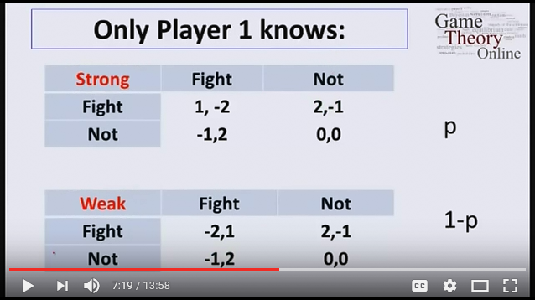
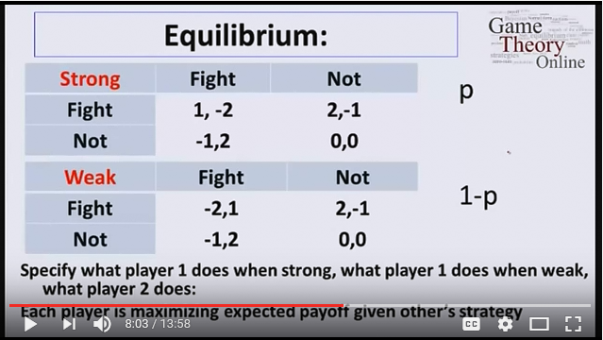

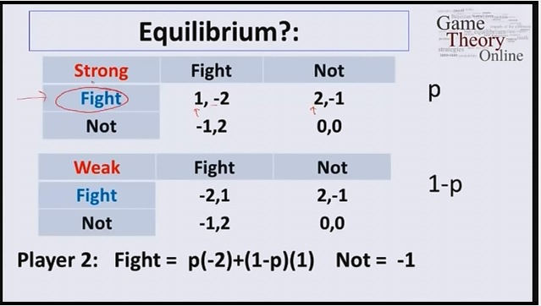

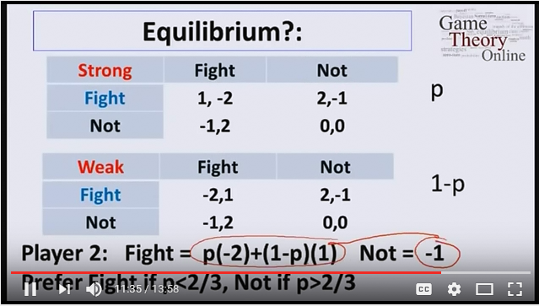

Player 2’s best response depends on prob. P
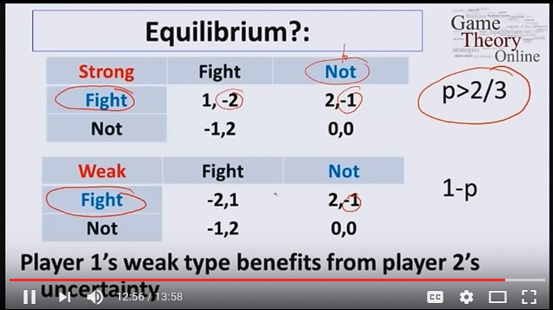

WE have a different Equilibrium than that of a complete information game.

