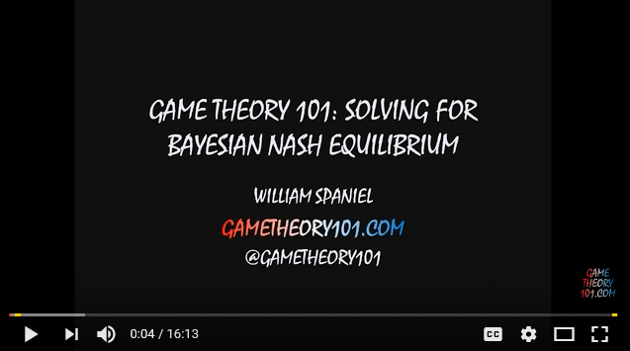

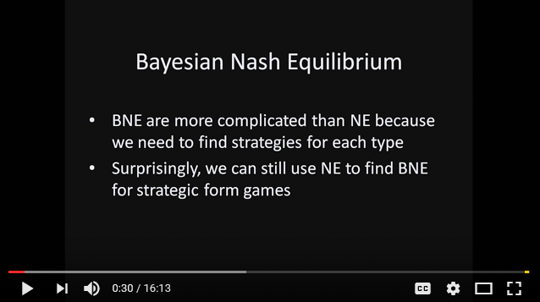

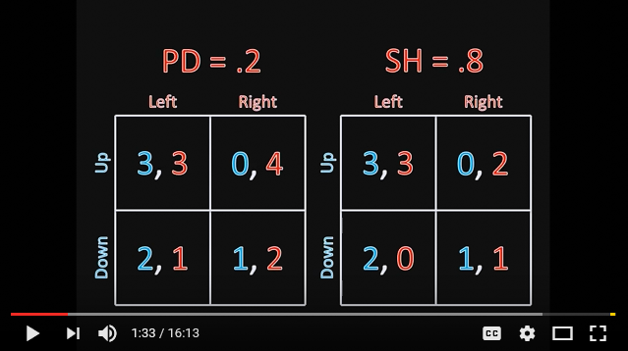

Player 2 is either a PD (Prisoner Dilemma) or a SH (Stag Hunts) player with given probabilities.
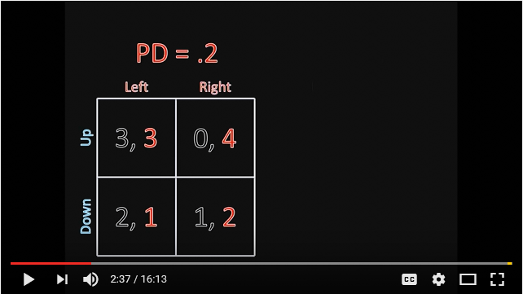

İf she is PD type will play Right.
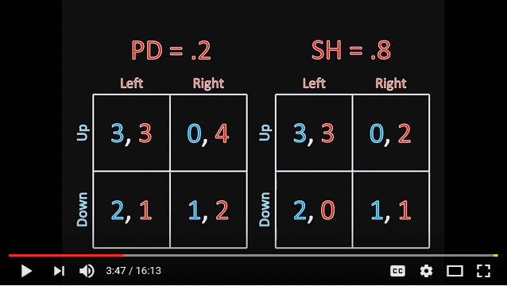
Player 1 has a problem. İf Player 2 is of type SH then Player 1 has common interest with him. On the other hand Player 1 is in conflict with Player 2 if player 2 is of PD type. How Should Player 1 respond to the situation?
We combine all the types into a single strategic game table.
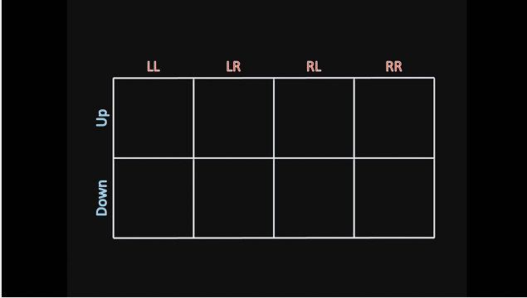
LR means Player 2 plays L if she is of type PD and plays R if she is of type SH.
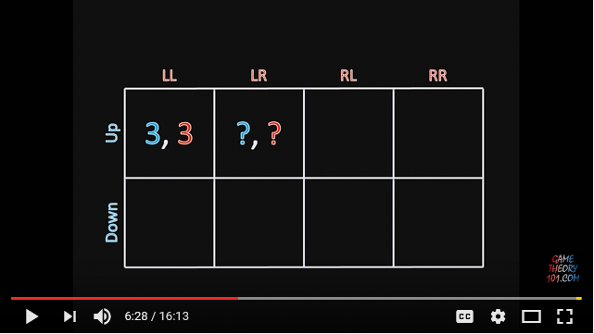
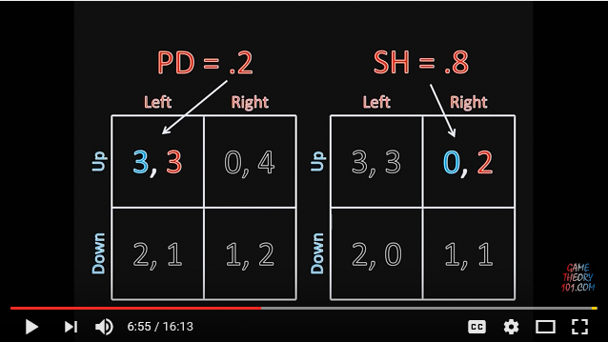
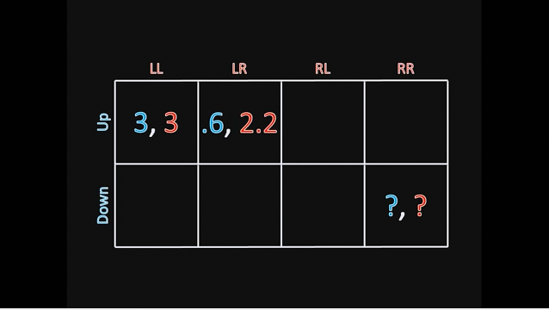

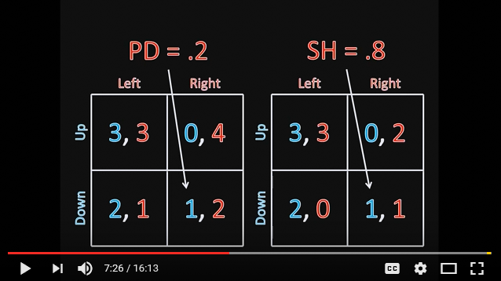
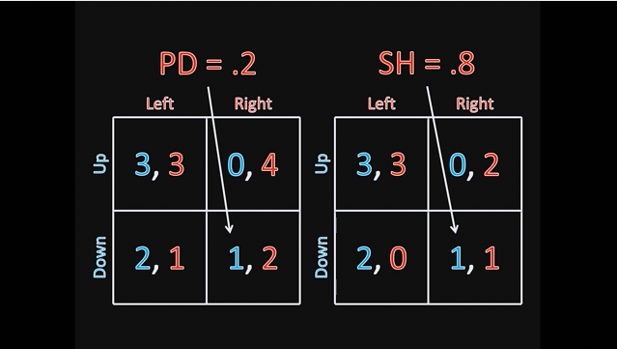

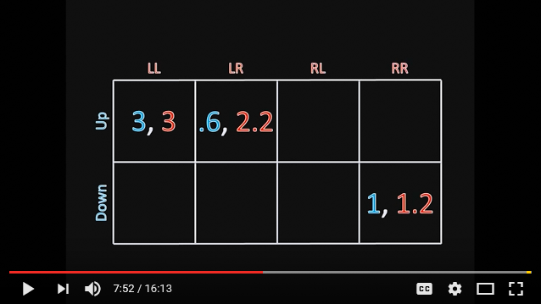

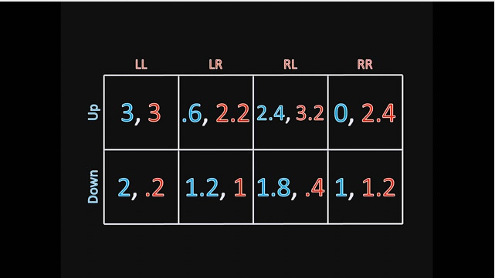

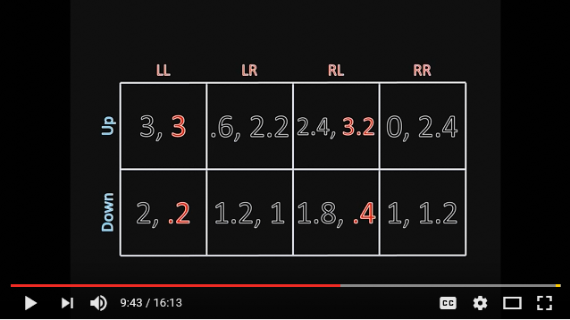

Let’s compare strategies LL and RL. Clearly LL is dominated.
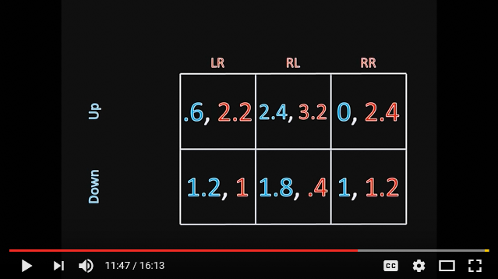

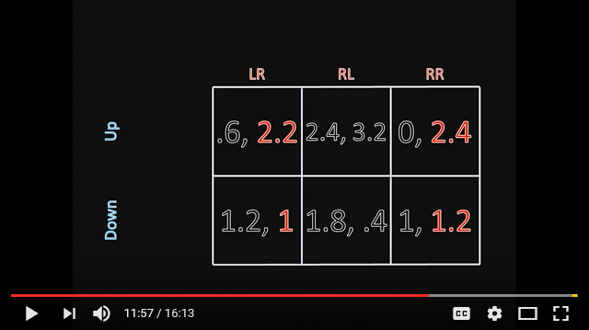

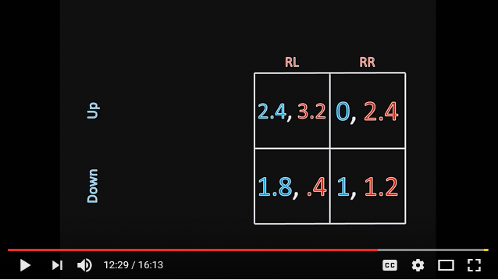
At this point no more dominated strategies.

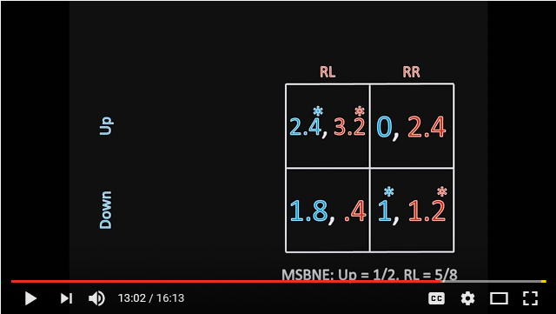

Three Bayesian NE: (Up, RL), (Down, RR) and ((1/2,1/2), (R, 5/8,3/8))

