UBİ/UTİ 553 Game Theory
HOMEWORK 2
Due date: Oct. 17th/18th, 2018
Ack. Questions are taken from web sites of Dr. L. Kockesen of Koç University
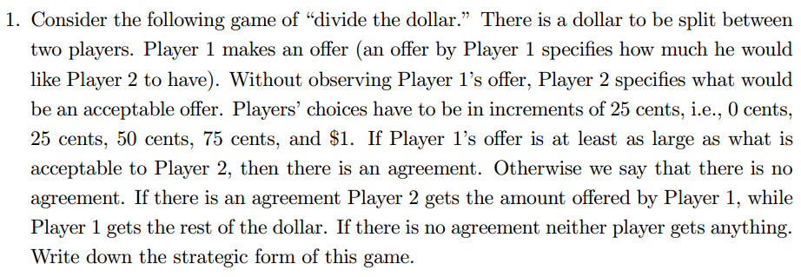 Also give the bimatrix form of the game.

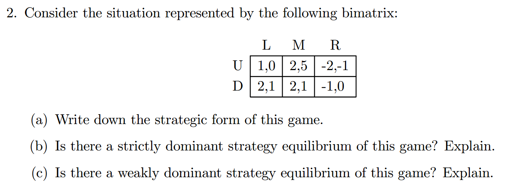
Note that strategic form comes in two representations:
- Matrix form (if there are two players, bimatrix)
- Explicit form which is composed of Set of players, set of strategies for each player and payoff function for each player

