UBİ/UTİ 553 Game Theory
HOMEWORK 3
Due date: Oct. 24th/25th, 2018
- Ack. Taken from web site of Dr. Kevin-Leyton Brown of Univ. of British Columbia.
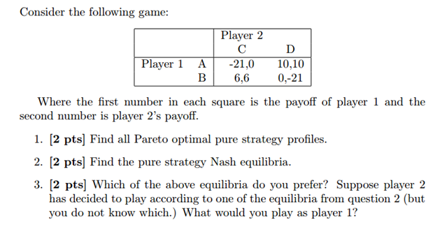
- Ack. Taken from web sites of Dr. Levent Koçkesen of Koç University.
