UTİ/UBİ 553 Game Theory
HOMEWORK IV
Due date: Oct. 31st/Nov. 1st, 2018
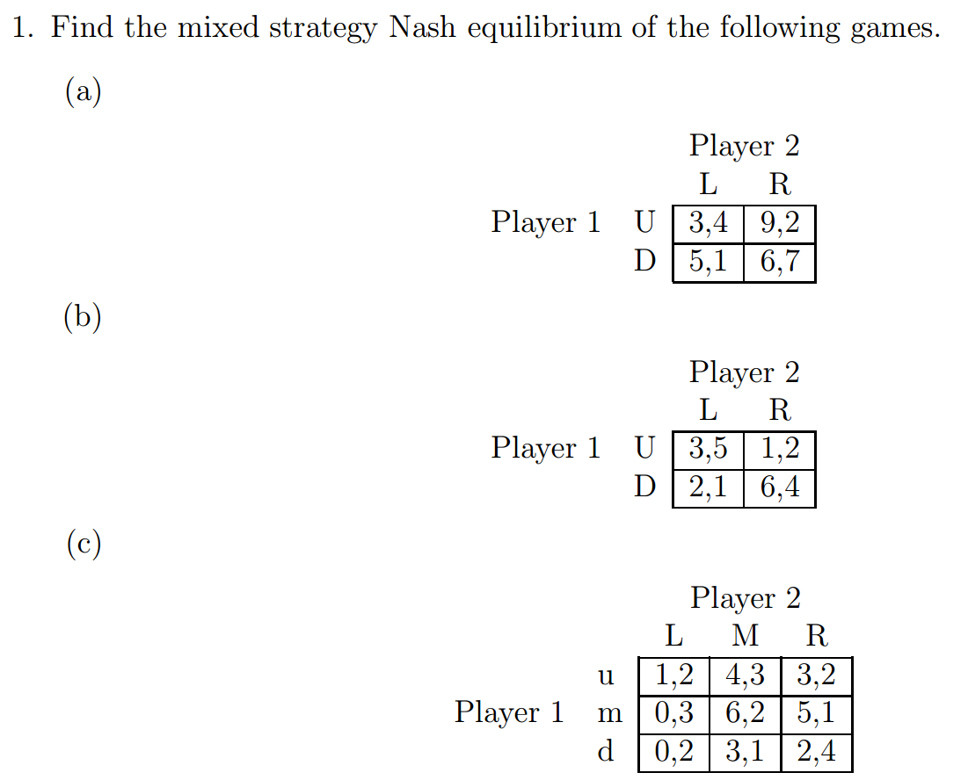

2. Find the Best Response Correspondance Graphics for the first two games above. Denote Player 1’s strategy as p (probability of choosing action U) and that of Player 2 as q (probability of choosing action L).
Note: For an example of the Best Response Correspondance Graphics see Slides 13/18 of the Mixed Strategies Lecture by L. Kockesen.

