UTİ/UBİ 553 Game Theory
HOMEWORK V
Due date: Nov 7th/9th, 2018

1. (10 p) It is a two player simultaneous move game and each of two players announces an integer between 0 and 100. Let a₁ be the announcement of Player 1 and a₂ be the annoucement of Player 2. The payoffs are determined as follows.
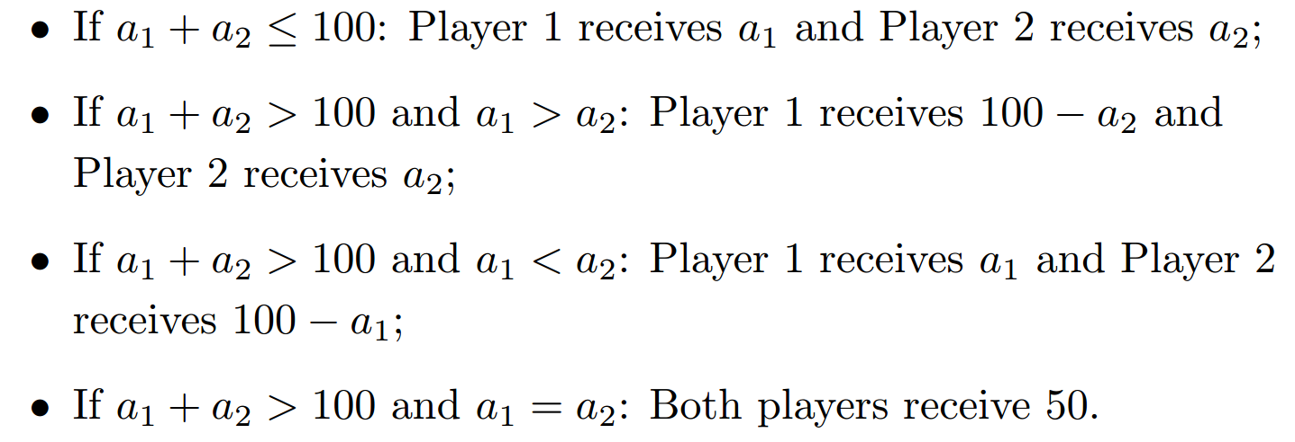
Find the Nash Equlibrium (or Equilibria) for this game.

- (20 p) Consider the following variation to the Rock (R), Paper (P), Scissors (S) game:
- Suppose that the Player 1 (row player) has a single type, Normal.
- Player 2 (column player) has two types Normal and Simple.
- A player of Normal type plays this zero-sum game as we studied in class whereas a player of type Simple always play P.
- Player 2 knows whether he is Normal or Simple, but player 1does not.

- Suppose player 2 is of type Normal with probability 1/3 and of type Simple with probability (2/3). Find all pure strategy Bayesian Nash Equilibria.

- Suppose player 2 is of type Normal with probability 2/3 and of type Simple with probability (1/3). Find all pure strategy Bayesian Nash Equilibria.

