UBİ/UTİ 553 Game Theory
HOMEWORK VI
Due date: Nov 28/29th, 2018
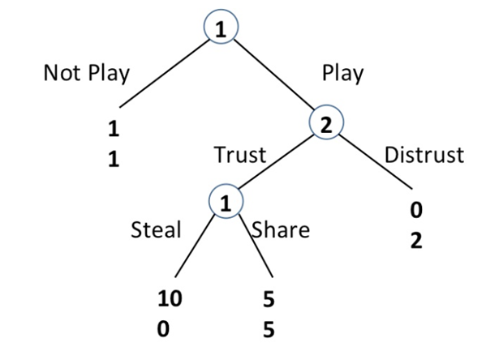
1. a) Find all of the pure strategy Nash Equilibria of the above game. There can be more than one eq.
b) Find the Subgame Perfect Equilibrium (SPE) of the above game.

Note : Use the following sample notation: ((Not Play, Steal), (Trust)) indicates that player 1 chooses Not Play at the first decision node and Steal at the second decision node, and Player 2 chooses Trust at his unique decision node.

2.
