UBİ/UTİ 553 Game Theory
HOMEWORK VIII
Due date: Dec 12th/13th, 2018

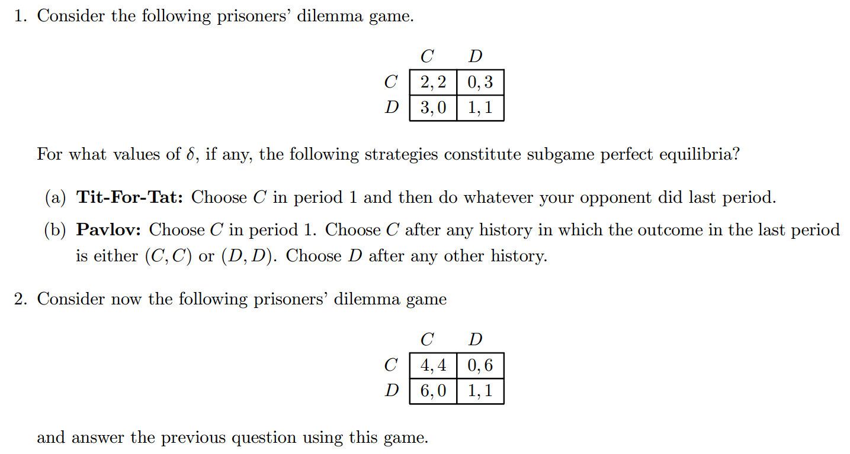

Hints:
