UTI513 Homework #4
Due date 6th of November 2019

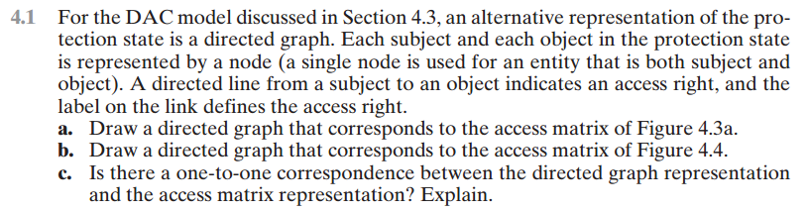
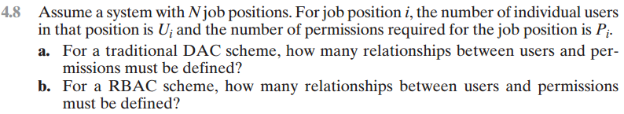
Some review problems for you to study for the exams.
