UBI602 Homework #8

Due date: May 11th, 2015

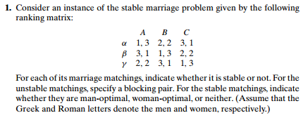

2.



3. Design a simple algorithm for checking whether a given marriage matching is stable and determine its time efficiency class.

4.

