UBI602 Homework #9

Due date: May 12th, 2014

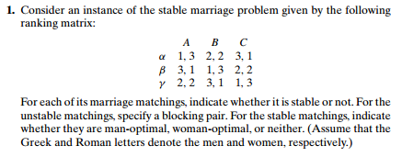

2.



3. Design a simple algorithm for checking whether a given marriage matching is stable and determine its time efficiency class.

4.

