Homework 7 (Spring 2017)
7.1.4. Is the comparison-counting algorithm stable?
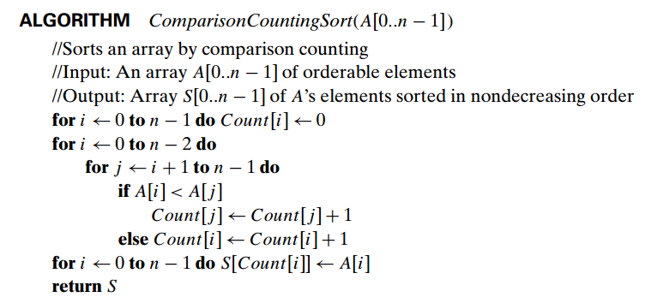
7.1.8. (Least distance sorting) There are 10 Egyptian stone statues standing in arow in an art gallery hall. A new curator wants to move them so that the statues are ordered by their height. How should this be done to minimize the total distance that the statues are moved? You may assume for simplicity that all the statues have different heights.
7.2.1. Apply Horspool’s algorithm to search for the pattern SORTING in the text
SORTING_ALGORITHM_CAN_USE_BRUTE_FORCE-METHOD
7.3.5. (Birthday parodox) The birthday paradox asks how many people should be in a room so that chances are better than even that two of them will have the same birthday (month and day). Find the quite unexpected answer to this problem. What implication for hashing does this result have?

