Table of Contents

Instructions to use JDBC in Eclipse 1
Sample stored procedures and how to execute them through JDBC 2
STORED PROCEDURE THAT INSERTS DATA 2
STORED PROCEDURE THAT READS DATA 3
JAVA CODE TO CALL THE PROCEDURE THAT INSERTS DATA 3
JAVA CODE TO CALL THE PROCEDURE THAT READS DATA 3

Instructions to use JDBC in Eclipse
- You will need the JDK to develop java projects with eclipse. Download and install the latest JDK (Go for Java EE 6 SDK):
http://java.sun.com/javaee/downloads/index.jsp
- Download and extract Eclipse (Go for Eclipse for Java EE developers):
http://www.eclipse.org/downloads/
- Download the Connector/J library from mysql:
http://dev.mysql.com/downloads/connector/j/
- Extract the ZIP (or TAR) archive and place the file mysql-connector-java-5.1.12-bin.jar on your hard drive (i.e. Desktop).
- Attach the JAR file to your eclipse project:
  - Go to properties of your project:
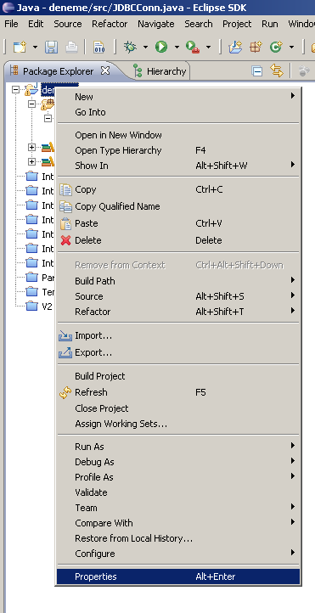
  - Using the “Add External JARs” button, attach the JAR file you have downloaded from MySQL.
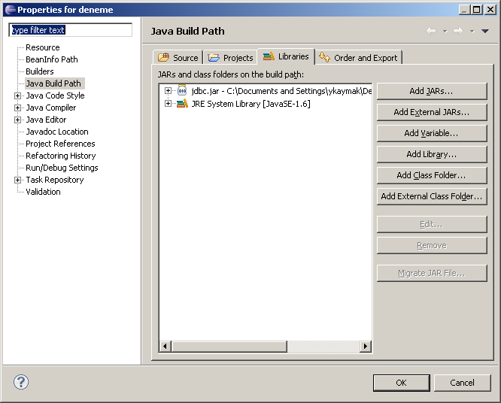
  - Now you can run the sample codes provided in the class.

Sample stored procedures and how to execute them through JDBC

STORED PROCEDURE THAT INSERTS DATA

DELIMITER $$
CREATE PROCEDURE CreateShipLaunchedToday (shipName varchar(30), className varchar(30))
BEGIN
INSERT INTO Ships(name, class, launched)
VALUES (shipName, className, YEAR(CURDATE()));
END $$

STORED PROCEDURE THAT READS DATA

DELIMITER $$
CREATE PROCEDURE FindAverageNumberOfGunsForCountry(countryName varchar(30), OUT countryAverage INT)
BEGIN
SELECT AVG(numGuns) INTO countryAverage FROM classes WHERE country=countryName;
END $$

P.S. Don’t forget to change your password field in the the line below before using the java classes:
con = DriverManager.getConnection("jdbc:mysql:///ships","root", "password");

JAVA CODE TO CALL THE PROCEDURE THAT INSERTS DATA

import java.io.BufferedReader;
import java.io.InputStreamReader;
import java.sql.Connection;
import java.sql.DriverManager;r
import java.sql.SQLException;
import com.mysql.jdbc.CallableStatement;

public class sqlmain {
public static void main(String[] args) {
Connection con = null;

try {
Class.forName("com.mysql.jdbc.Driver").newInstance();
con = DriverManager.getConnection("jdbc:mysql:///ships",
"root", "password");

if(!con.isClosed())
System.out.println("Successfully connected to " +
"MySQL server using TCP/IP...");

CallableStatement callStatement = (CallableStatement) con.prepareCall("CALL CreateShipLaunchedToday(?, ?, ?)");
String CurLine="";
System.out.println("Enter the ship name: ");
InputStreamReader converter = new InputStreamReader(System.in);
BufferedReader in = new BufferedReader(converter);
CurLine = in.readLine();
callStatement.setString(1, CurLine);
System.out.println("Enter the ship class: ");
CurLine = in.readLine();
callStatement.setString(2, CurLine);
System.out.println("Enter the launch year: ");
CurLine = in.readLine();
callStatement.setString(3, CurLine);
callStatement.execute();
System.out.println("A new row has been insterted successfully");

} catch(Exception e) {
System.err.println("Exception: " + e.getMessage());
} finally {
try {
if(con != null)
con.close();
} catch(SQLException e) {}
}

}
}

JAVA CODE TO CALL THE PROCEDURE THAT READS DATA

import java.io.BufferedReader;
import java.io.InputStreamReader;
import java.sql.Connection;
import java.sql.DriverManager;
import java.sql.SQLException;
import com.mysql.jdbc.CallableStatement;

public class sqlmain {
public static void main(String[] args) {
Connection con = null;

try {
Class.forName("com.mysql.jdbc.Driver").newInstance();
con = DriverManager.getConnection("jdbc:mysql:///ships",
"root", "password");

if(!con.isClosed())
System.out.println("Successfully connected to " +
"MySQL server using TCP/IP...");

CallableStatement callStatement = (CallableStatement) con.prepareCall("CALL FindAverageNumberOfGunsForCountry(?, ?)");
String CurLine="";
System.out.println("Enter the country name: ");
InputStreamReader converter = new InputStreamReader(System.in);
BufferedReader in = new BufferedReader(converter);
CurLine = in.readLine();
callStatement.setString(1, CurLine);
callStatement.registerOutParameter(2, java.sql.Types.INTEGER);
callStatement.executeQuery();
int myAverage = callStatement.getInt(2);
System.out.println("Average is: " + myAverage);

} catch(Exception e) {
System.err.println("Exception: " + e.getMessage());
} finally {
try {
if(con != null)
con.close();
} catch(SQLException e) {}
}

}
}

